# Chapter 1 and 2

## Assignment 1

In the folder “File for Homework Assignments” you will find three files named Climate_A.csv, Climate_B.csv, and Climate_C.csv. The files contain artificially generated monthly temperature averages. The first column is the month, the second column the year and the third column are the temperature in degrees Fahrenheit.

### Plot the temperature versus date as a scatter plot for the three files on separate plots

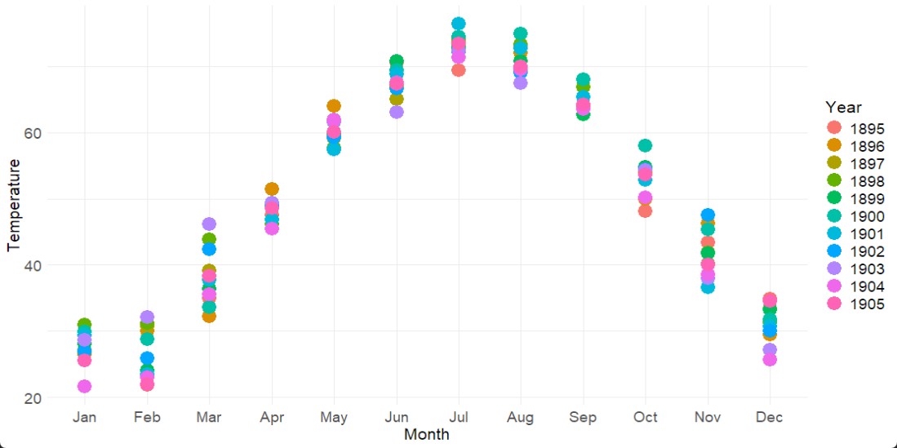

Figure 1: Temperature versus Date as a scatter plot of Climate_A data

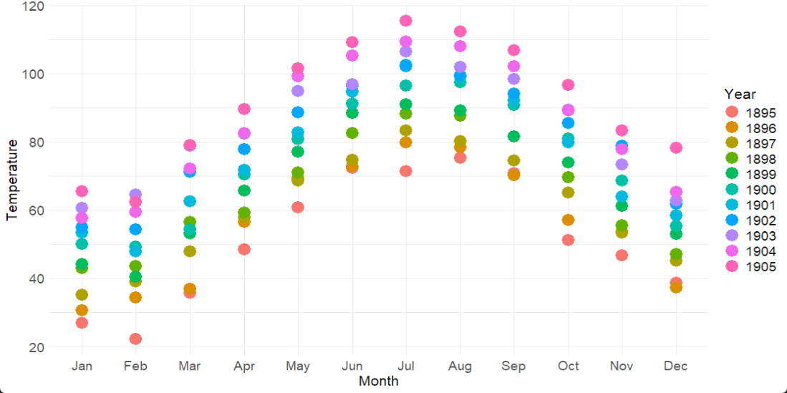

Figure 2: Temperature versus Date as a scatter plot of Climate_B data

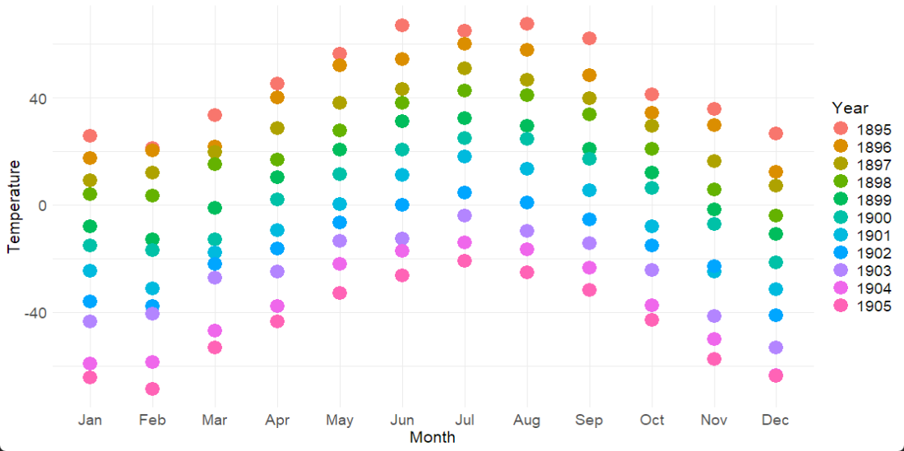

Figure 3: Temperature versus Date as a scatter plot of Climate_C data

### Plot the temperature versus date as a seasonal scatter plot for the three files on separate plots

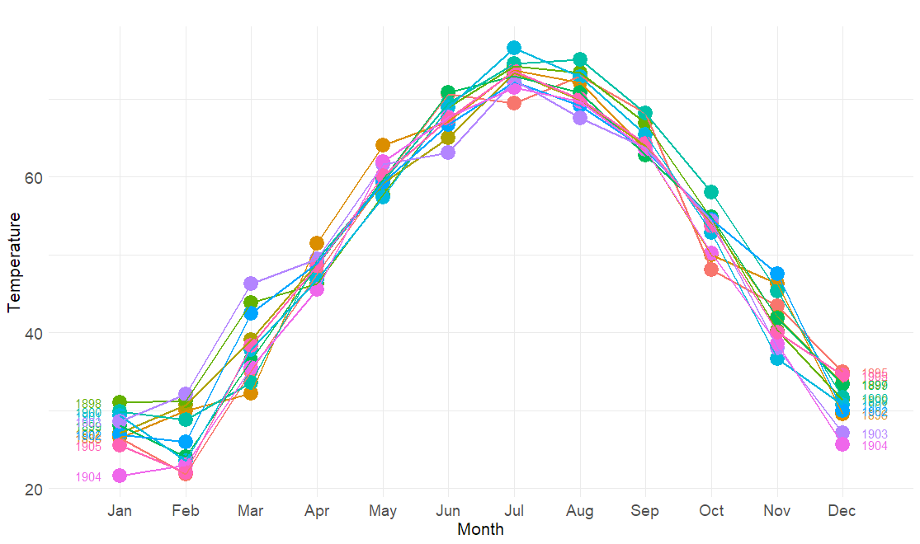

Figure 4: Temperature versus Date as a seasonal scatter plot of Climate_A data

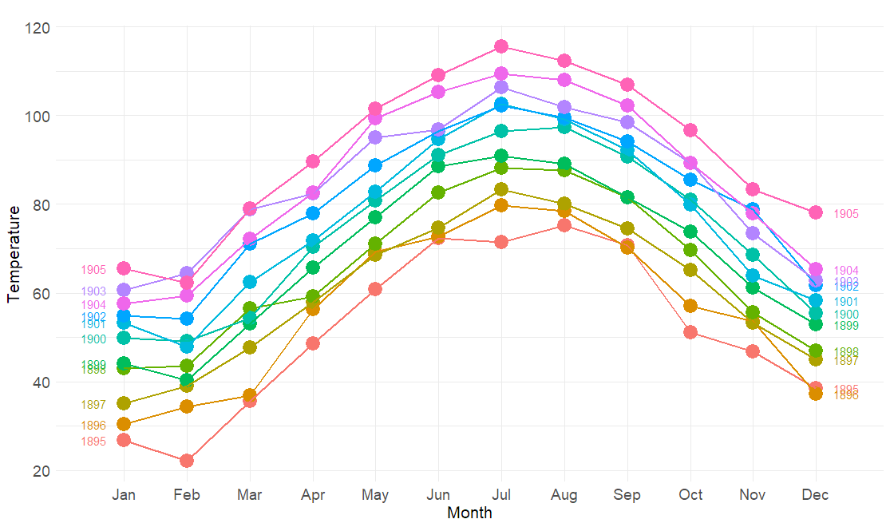

Figure 5: Temperature versus Date as a seasonal scatter plot of Climate_B data

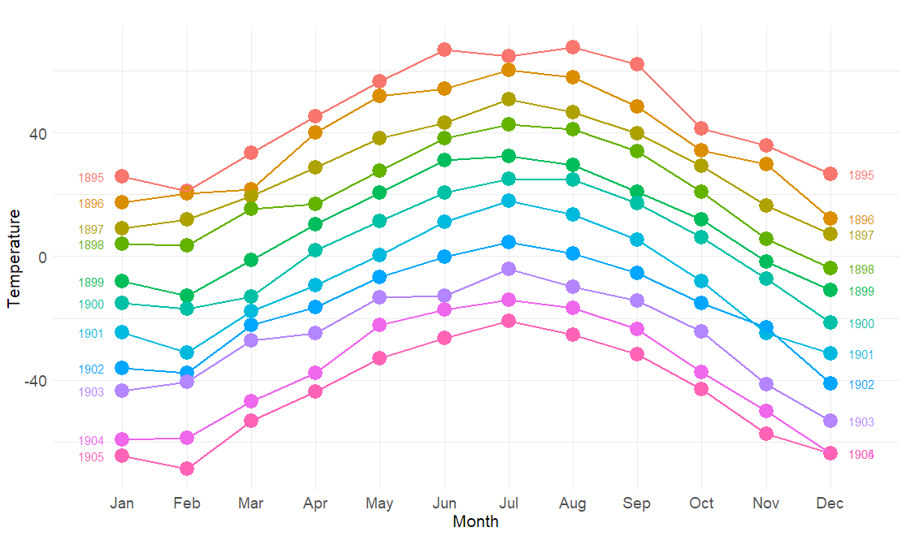

Figure 6: Temperature versus Date as a seasonal scatter plot of Climate_C data

### Plot the temperature versus date as a seasonal polar plot for the three files on separate plots

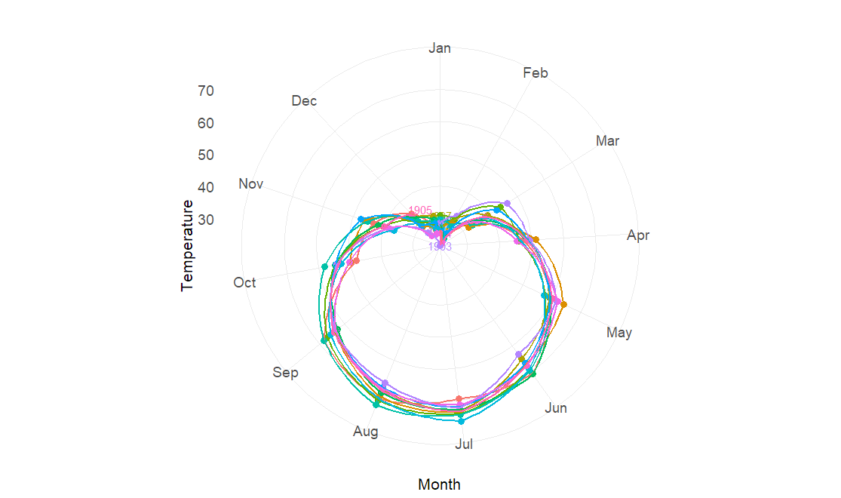

Figure 7: Temperature versus Date as a seasonal polar plot of Climate_A data

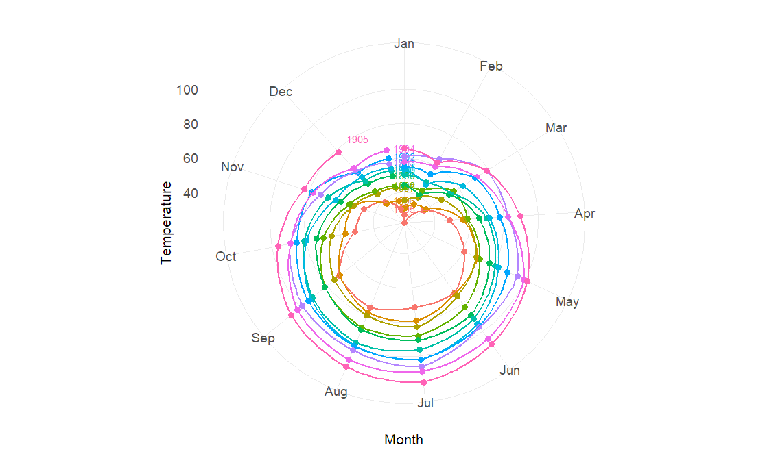

Figure 8: Temperature versus Date as a seasonal polar plot of Climate_B data

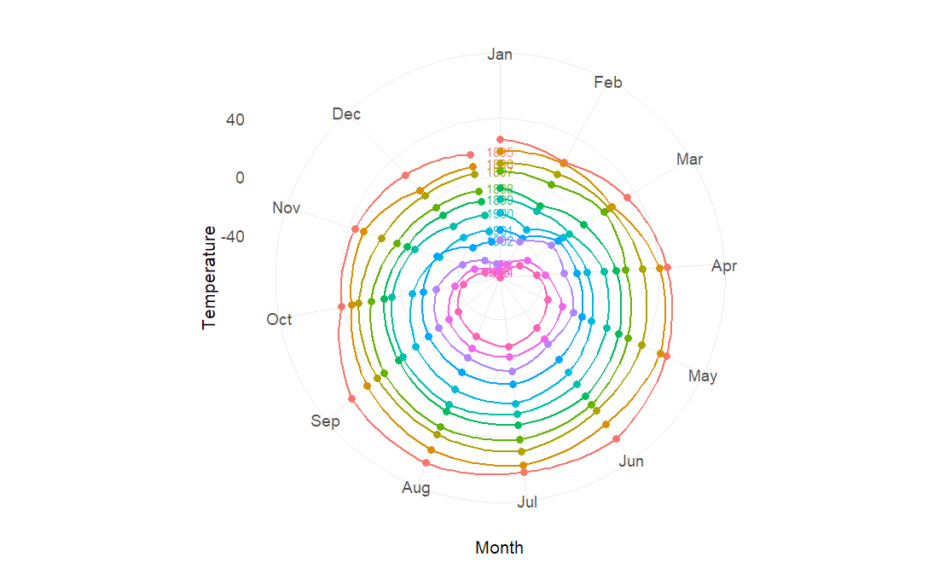

Figure 9: Temperature versus Date as a seasonal polar plot of Climate_C data

Describe differences between the three data files

**Similarities**

All three datasets, *Climate_A*, *Climate_B*, and *Climate_C* have data from 1895 to 1905. In all three graphs, the temperatures are hot during the summer months (June to August) and cold in the winter months (January and February). This shows that they all follow a similar seasonal pattern.

**Differences**

In *Climate_A*, the temperature changes from year to year are not very consistent. But for each month, the temperature differences between years are usually within 10°F. The lowest temperature is around 20°F, and the highest is close to 80°F.

In *Climate_B*, the temperature goes up over time, from 1895 to 1905. The coldest temperature is about 20°F, and the hottest temperature reaches almost 120°F, which is much hotter than in *Climate_A*.

In *Climate_C*, the temperature goes down over time, from 1895 to 1905. The lowest temperature is very cold, about -80°F, and the highest is around 80°F. This dataset has a much wider temperature range than the other two.

## Assignment 2

Monthly Australian retail data is provided in aus_retail. Select one of the time series as follows (but choose your own seed value):

**set.seed**(12345678)

myseries <- aus_retail **|>**

**filter**(`Series ID` **==** **sample**(aus_retail**$**`Series ID`,1))

## Explore your chosen retail time series using the following functions:

autoplot(), gg_season(), gg_subseries(), gg_lag(),

ACF() |> autoplot()

Can you spot any seasonality, cyclicity and trend? What do you learn about the series?

### autoplot()

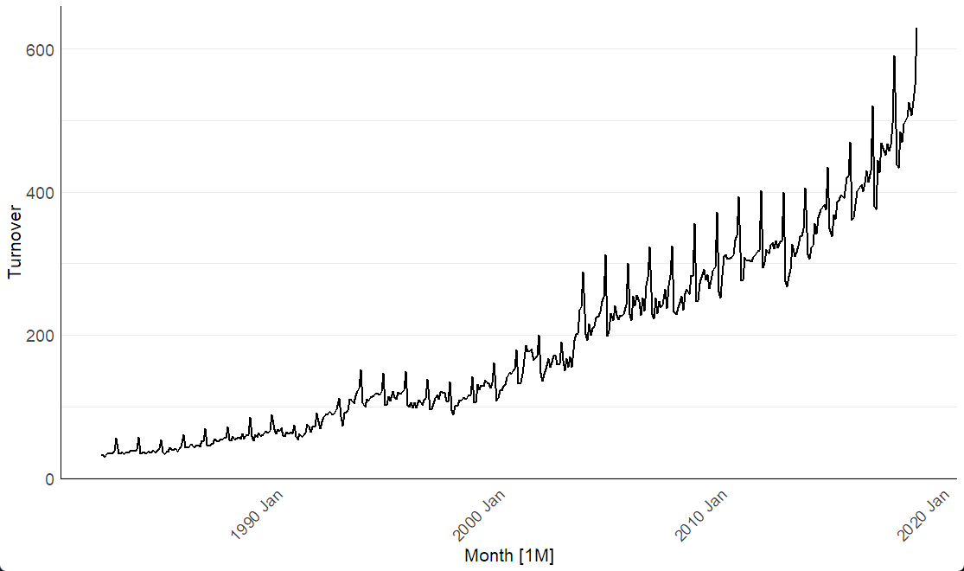

The graph shows a nonlinear upward trend in retail turnover from the late 1980s to 2020. The growth appears to accelerate over time, especially after the early 1994 and again after 2005. This suggests that retail sales are growing faster and faster.

### gg_season()

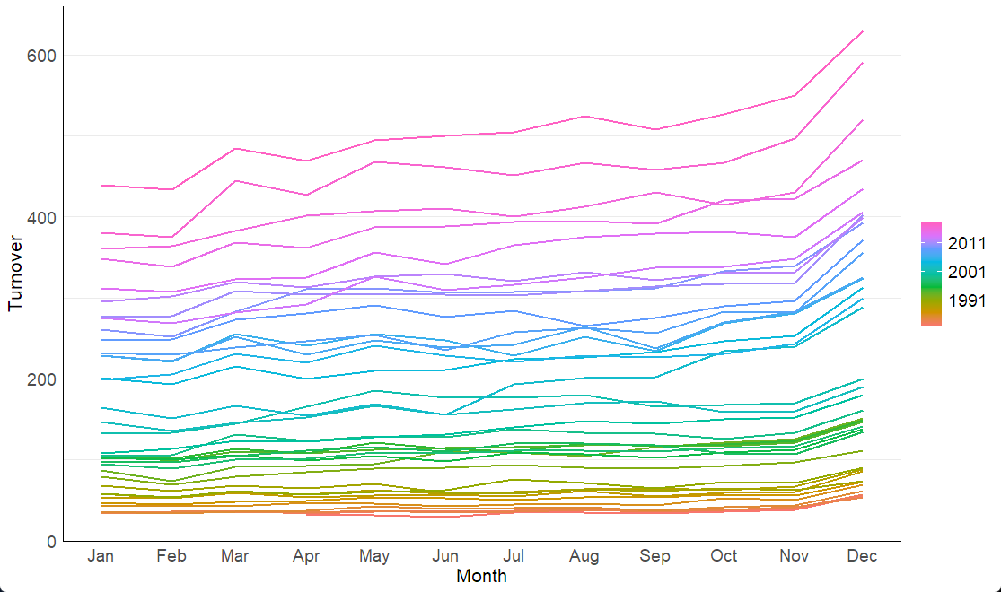

The plot shows that retail turnover increases over the years. Each line represents one year, and the colors gradually change from warm to cool. Turnover increases in December every year, likely due to holiday shopping.

### gg_subseries()

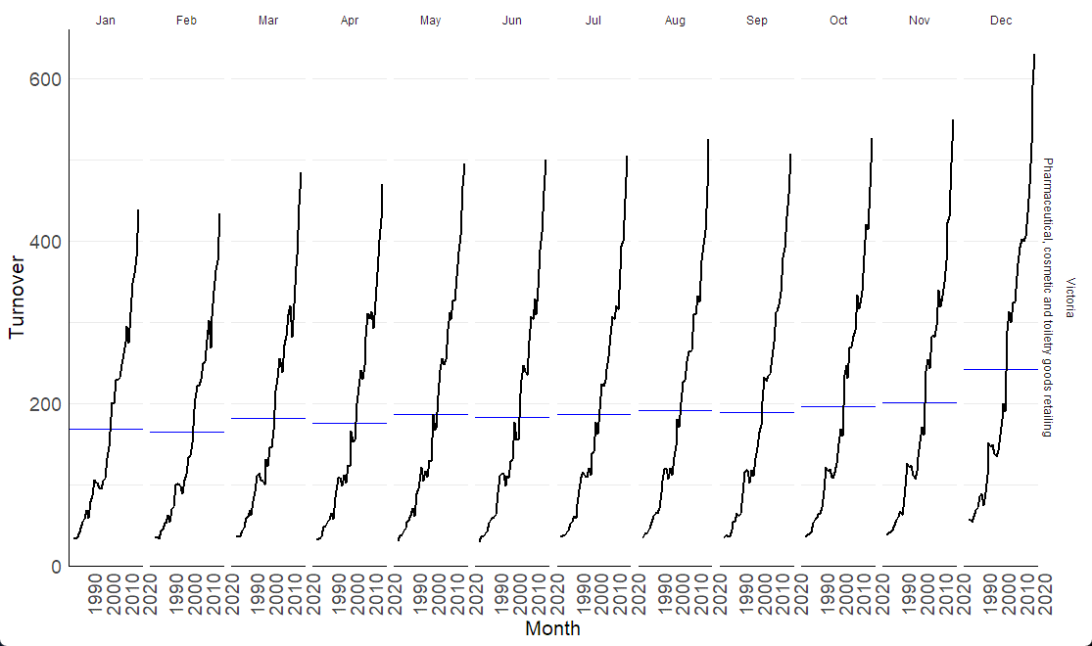

In every month, turnover generally increases over the years. However, there is a noticeable dip across all months during the 2000s and 2015s. The December panel still shows the highest turnover values each year.

### gg_lag()

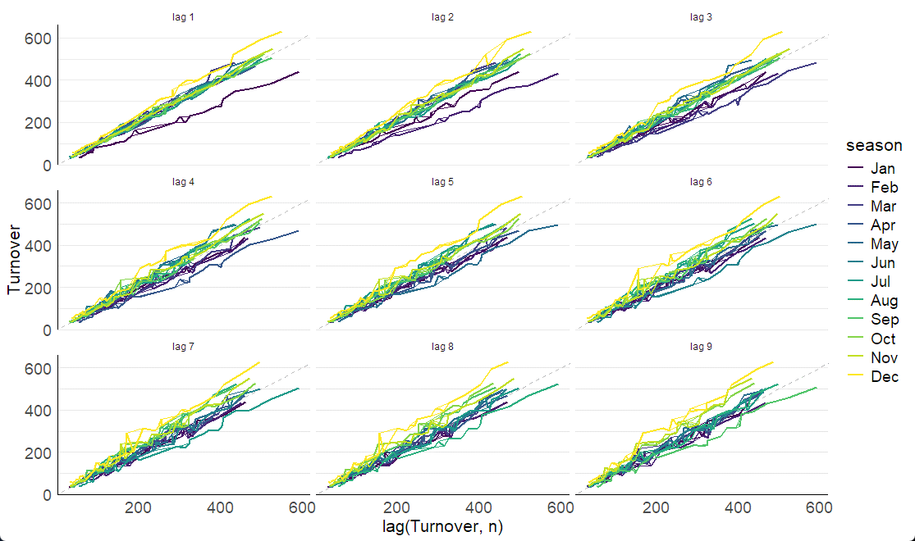

In all panels, the points and lines mostly follow a positive upward trend, this is a sign of strong autocorrelation.

### ACF() |> autoplot()

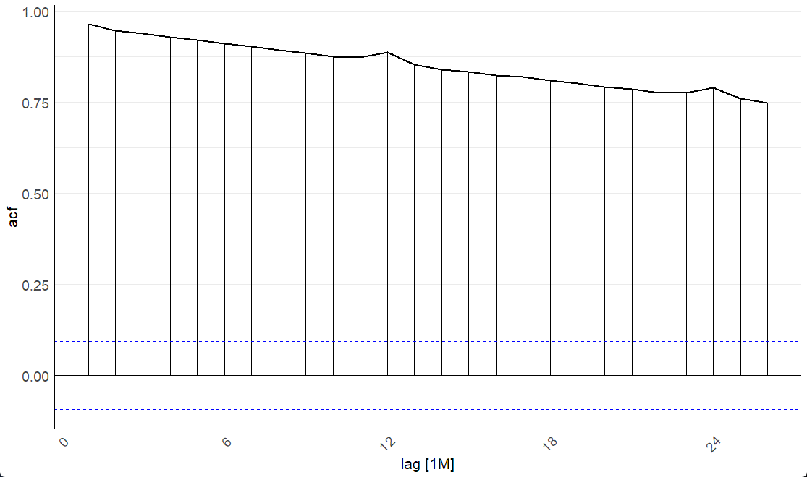

The first few bars are very high indicates there's a strong short-term relationship between months. The autocorrelation decreases slowly as the lag increases, but it still remains high after 24 months. There's a small increment at lag 12 and lag 24, which suggests a seasonal pattern that repeats yearly.